****VSFTPD** (Very Secure FTP Daemon)server**

**What is vsftpd:**

**VSFTPD** (Very Secure File Transfer Protocol Daemon) is an open-source, lightweight, and highly secure **FTP server** designed for Unix-like operating systems, such as Linux. It allows users to transfer files between a client and a server using the **FTP (File Transfer Protocol)**

**Setting up VSFTPD server:**

**SERVER SIDE;**

**Install vsftpd packages:**

**[root@server ~]# yum install vsftpd**

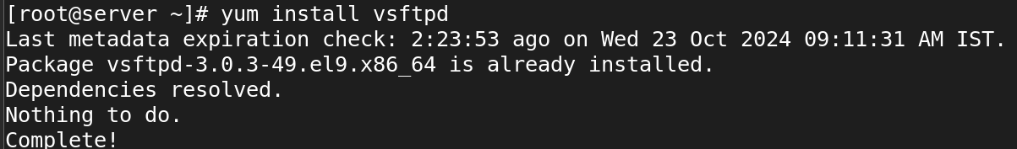

**The above vsftpd packages was all ready install while doing yumrepo config.otherwise install yum vsftpd packages and after installing packages newly we should config the **/etc/vsftpd/vsftpd.config** in that config we should enable anonymous--YES .**



After change in vsftpd config we should restart the service

**[root@server ~]# systemctl restart vsftpd.service**

Next step we should go to /var/ftp/car in that dir we should put some file like /etc/config*

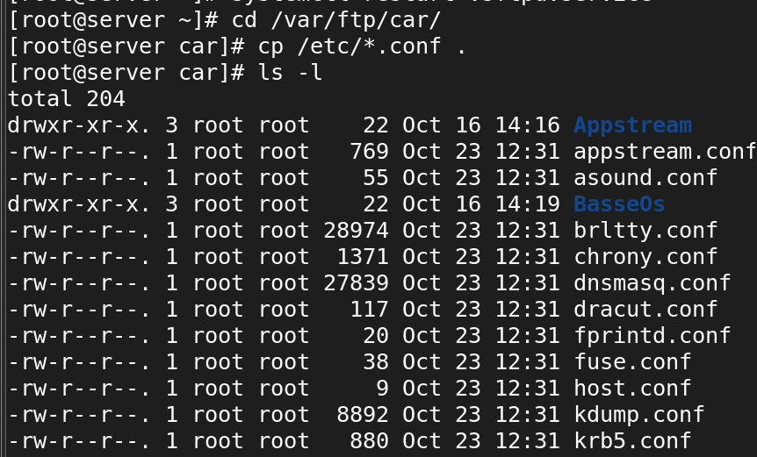

**Client side :**

First step to install ftp packages:-

**[root@client ~]# yum install ftp**

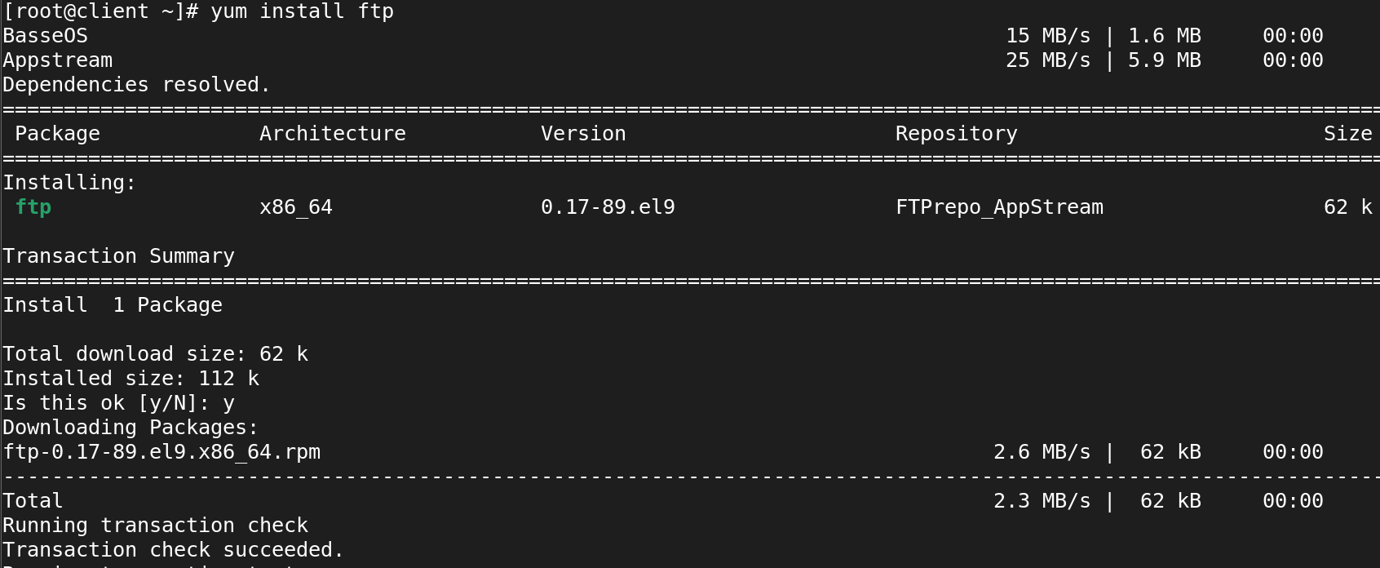

Next step to go server domain name using ftp

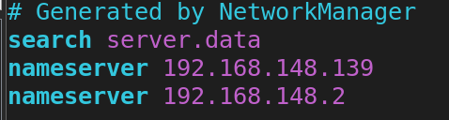

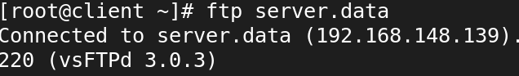

Now you should give an rootuser name as an anonymous

And skip the passwd and it show currently in ftp dirctory.

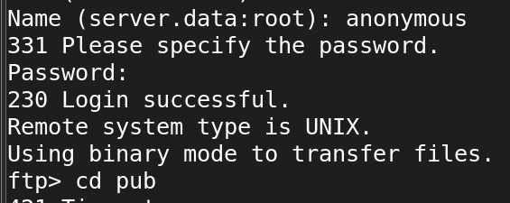

Now in the yumrepo we crerated the /var/ftp/car.. dir in that the basseos and apppstream pakages will show.

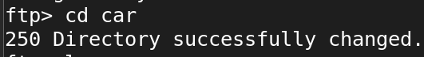

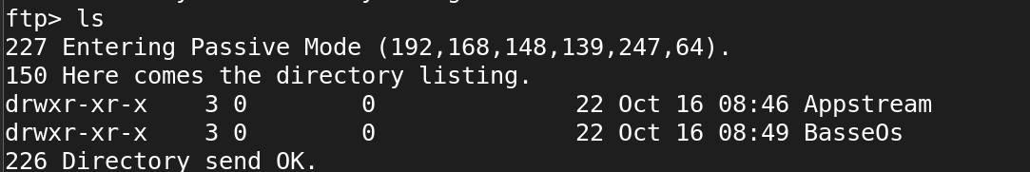

After cd-- car now I viweing the dir car in that it will show all etc conf. * files

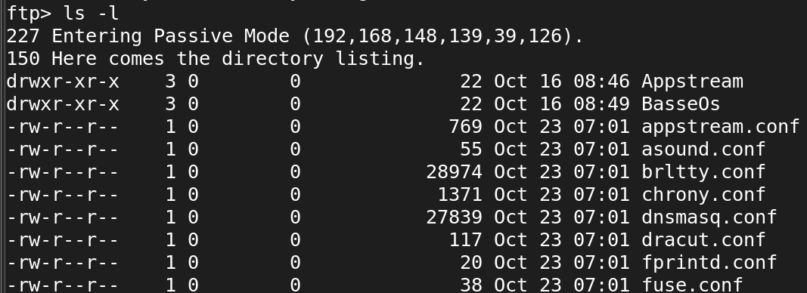

Next step to install the config files from the car dir

**Command --> ftp> get yum.conf**

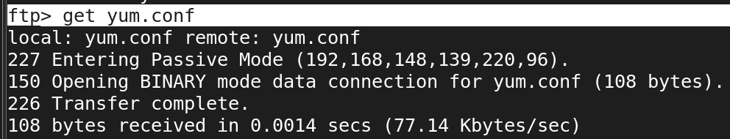

To install multiple files we use

**Command --> ftp>mget yum.conf resolve.conf**

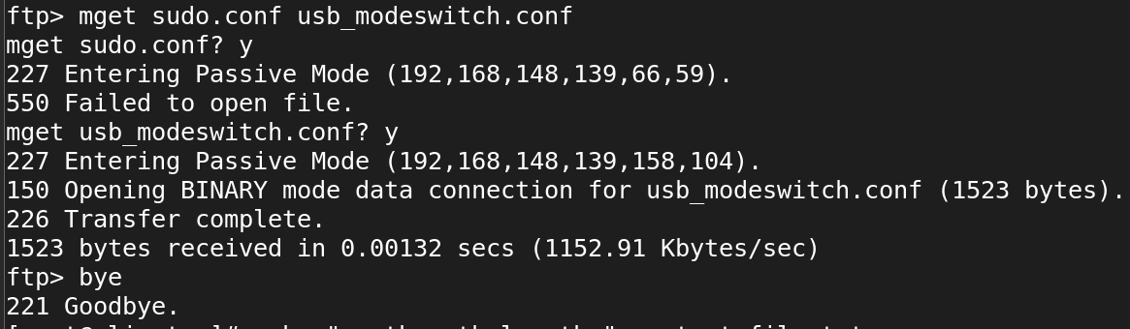

Now we use to upload file to the car dir

First step to we should create an file in current dirctory in car.

**ftp> !echo "spvp" >> file2**

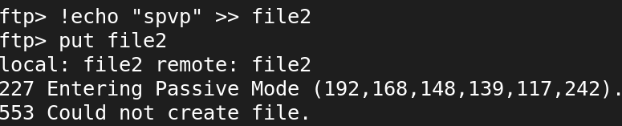

Now ,We coudnt create a file. because we should modife two steps in server side before we create an file

**Step : 1**

We should give full permission to the /var/ftp/car--> dir

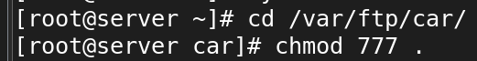

**Step : 2**

Next step we should modife the vsftpd config file.

**[root@server ~]# vi /etc/vsftpd/vsftpd.conf**



Now we should remove an # to activate an command



Next step to restart the vsftpd service

**[root@server car]# systemctl restart vsftpd.service**

Now we can upload file in the directry car.

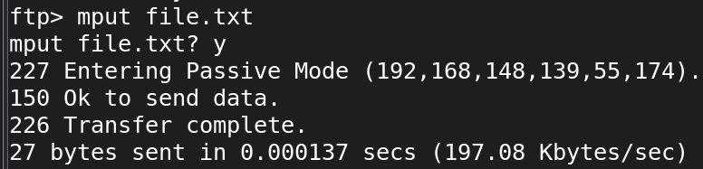

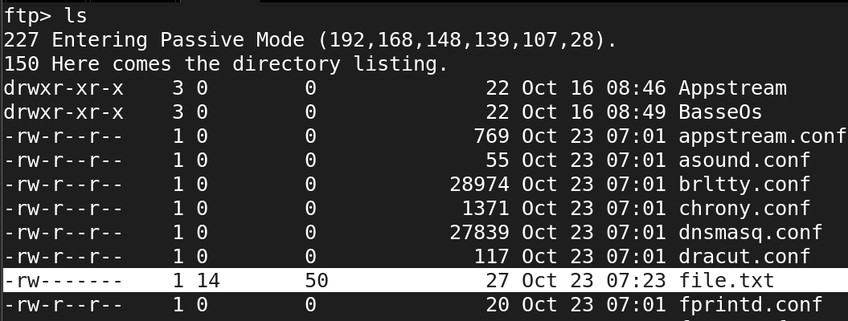

By using 2 method we can login . then we can download and upload the file

The above method is method 1 ↑

**Method 1-->anonymous login (we no need to give passwd)**

**Method 2-->userlogin (we should we an passwd)**

The below method is method 2 ↓

**Now we should create an 1 user and create an passwd in server side.**

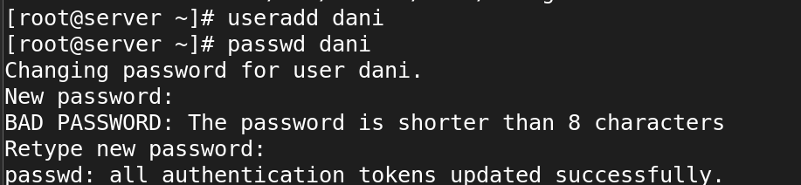

Now we use to cd ftp and ls

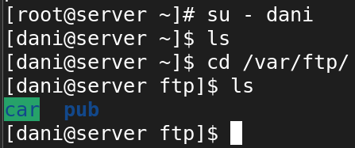

Now in client side we can change dir to car from full path /var/ftp/car..

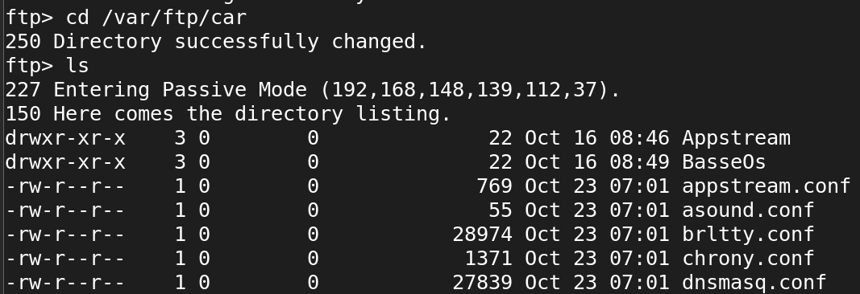

Now we can download and upload as in above steps:

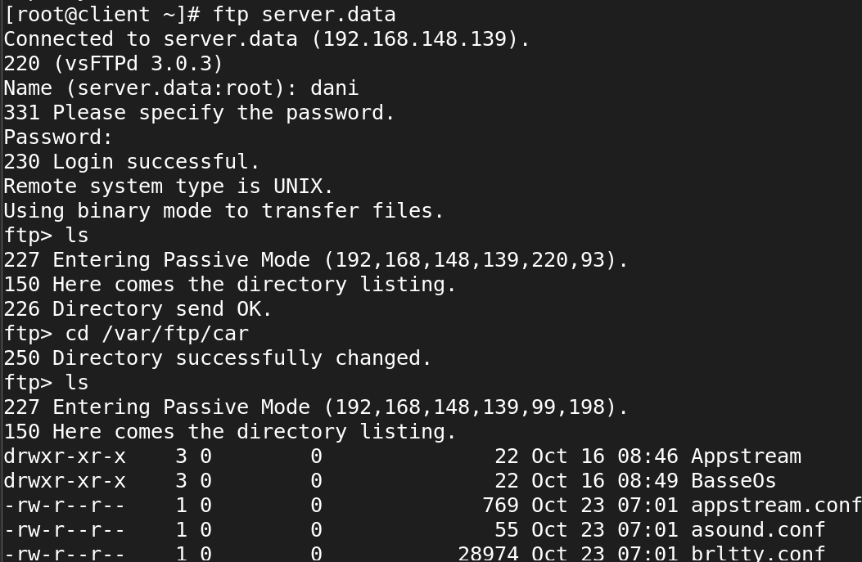

Now we can put and get the file

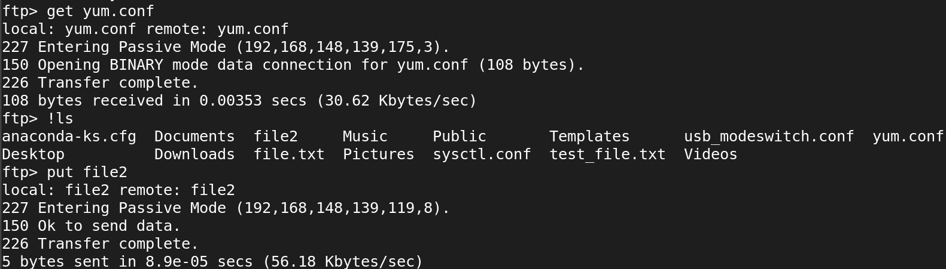

Ls --> file after uoplad

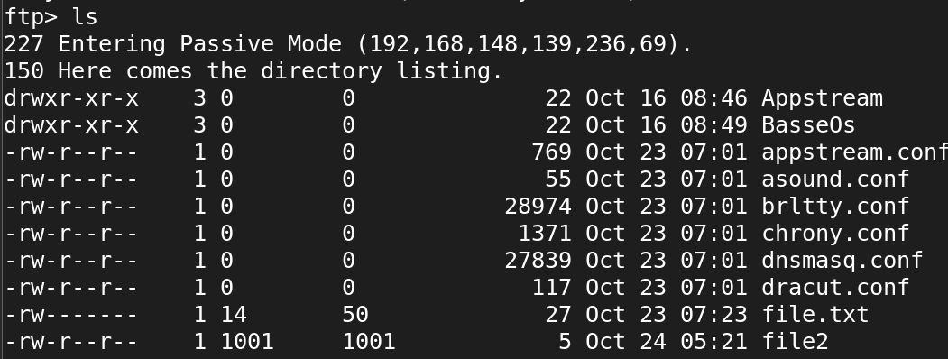

Same we can download and upload multiple file using mget and mput command.

Now we use to block the dani user to login into the ftp > server.data

First we should switch from normal user to root user in server side.

**[dani@server ~]$ exit**

**logout**

Now we should config the file .

**[root@server ~]# vi /etc/vsftpd/ftpusers**

In the config file we can enter the user name not to login in ftp

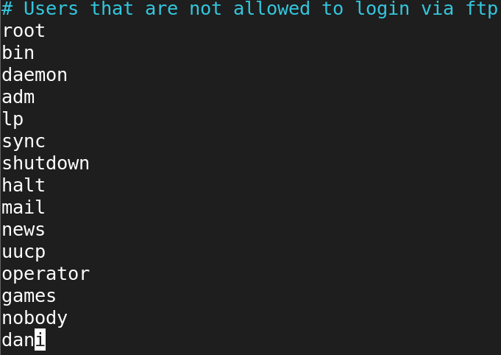

Now we should restart the service

**[root@server ~]# systemctl restart vsftpd.service**

Now su -dani

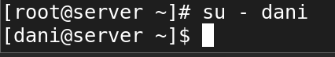

Now in client side we use to login using dani user we cant login.

